Nina Gregori takes up duties as Executive Director of EASO

* 17TH JUNE 2019

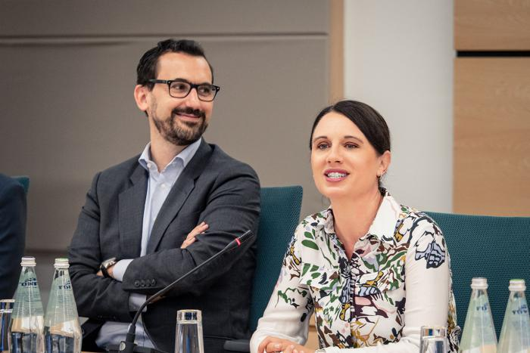

***New Executive Director committed to a forward-looking approach and to sustaining the progress made by the Agency over the past year.***

On 16 June 2019, Ms. Nina Gregori took up her duties as the new Executive Director of the European Asylum Support Office (EASO), based in Malta. Ms. Gregori, a Slovenian national, most recently served as Director-General responsible for the area of asylum, migration, integration, internal administrative affairs and naturalization, within the Slovenian Ministry of the Interior.

Ms. Gregori was selected to be the new Executive Director at the 31st meeting of the EASO Management Board, on 18 February 2019. Her appointment was subsequently confirmed by the Management Board following a positive opinion by the European Parliament. Ms. Gregori takes over from Mr. Jamil Addou, who has served as EASO’s Executive Director *ad interim* since 6 June 2018.

Commenting on her new duties, **Ms. Gregori** stated: “*I am honoured to be entrusted to lead EASO over the coming years. The Agency has a unique mandate, which, at its core, stands for upholding the very best of the EU’s principles in protecting those in need. EASO has gone through a challenging period, but is now turning the corner. I am committed to sustaining the progress that has been made over the past year in improving the Agency’s governance. By supporting this momentum and through a forward-looking approach we will continue delivering on the increasing demands for EASO’s support*.”

Ms. Gregori, whose first working day coincided with the 32nd meeting of the EASO Management Board, also paid tribute to the hard work carried out by Mr. Addou over the past year, most notably in relation to strengthening good governance and consolidating trust.

The new Executive Director will be presenting the EASO Annual Report on the Situation of Asylum in the EU on Monday, 24 June 2019, in Brussels. More information can be found [here](https://www.easo.europa.eu/easo-annual-report).